Web and Social Computing
Lab Assignment 2
Submitted to : Dr. Sowmya Kamath
Submitted by : Shaikh Sahil Ahmed
Roll number : 192IT022

Dataset 1: wiki-Vote
Dataset 2: p2p-Gnutella04
Dataset 3: p2p-Gnutella06

Based on the earlier experiments using Dataset 1, 2 and 3 we calculated various parameters of graphs like geodesic, average clustering coefficient, strongly connected components, diameter, sparseness, k-connectedness and degree distribution. Now in this assignment, the task is to implement Erdos Renyi, Watts Strogatz and Barabasi Albert model with their properties.

A. Erdos Renyi
1. It is the simplest possible model to explain the random complex networks
2. Network is undirected
- Start with all isolated nodes that are having no edges. Now add edges between pair of nodes one at a time randomly.
- Two possible choices for adding edges randomly:
- Randomize edge presence
- Randomize node pairs
So, I have implemented the model using randomized node pairs.
Two parameters:
1. Number of nodes: n
2. Number of edges: m
Randomized node pair says that pick a pair of nodes at random among the n nodes and add an edge between them if already not present and repeat until exactly m edges have been added. This model is also represented by G(n,m).

Factors like degree distribution, average clustering coefficient and average shortest path length has been calculated. The function ‘gnm_random_graph(n, m)’ is used to generate random graph with given the value of n and m.

Dataset 1:
n = 7115
m = 103689

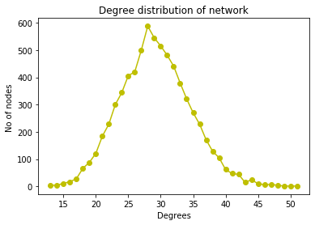
a) Degree distribution:

Fig 1. Degree distribution of Erdos Renyi model for dataset 1.

b) Average clustering coefficient = 0.004168010043203969
c) Average shortest path length = 2.919553280566207

Dataset 2:
n = 10876
m = 39994
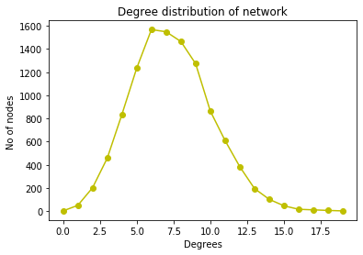
a) Degree distribution:

Fig 2. Degree distribution of Erdos Renyi model for dataset 2.

b) Average shortest path length :
As the graph is having 3 component:
1st component average shortest path length : 4.886061947407882
2nd component average shortest path length : 0
3rd component average shortest path length : 0

c) Average clustering coefficient = 0.0008810223770849435

Dataset 3:
n = 8717
m = 31525

a) Degree distribution:

Fig 3. Degree distribution of Erdos Renyi model for dataset 3.

b)Average shortest path length :
As the graph is having 7 component:
1st component average shortest path length : 4.810906805699634
2nd component average shortest path length : 1.0
3rd component average shortest path length : 0
4th component average shortest path length : 0
5th component average shortest path length : 0
6th component average shortest path length : 0
7th component average shortest path length : 0

c) Average clustering coefficient = 0.0007510166958574055

From the above calculations, it denotes that dataset 3 is having relatively low average clustering coefficient as compared to other two datasets. Dataset 3 is having 7 components.

B. Watts-Strogatz model

1. It is the effort to extend the Erdos Renyi model to a better predictor of real network properties, that is it addresses the poor prediction of clustering.
2. Most nodes are just a few edges away on average.

The function ‘watts_strogatz_graph(n,k,p,seed=None)’ is used for building the graph where n is number of nodes, each node is connected to k nearest neighbors in ring topology and p is the probability of rewiring each edge.

Dataset 1:

n = 7115
k = 12
p = 0.65
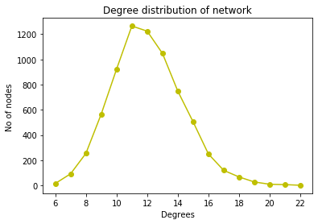
a) Degree distribution:

Fig 4. Degree distribution of Watts Strogatz model for dataset 1.

b) Average shortest path length : 3.8954970660526858
c) Average clustering coefficient = 0.03131629526512166

Dataset 2:
n = 10876
k = 12
p = 0.65

a) Degree distribution:

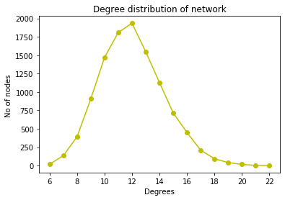

Fig 5. Degree distribution of Watts Strogatz model for dataset 2.

b) Average shortest path length : 4.081984333320651
c) Average clustering coefficient = 0.029920304015337122

Dataset 3:

n = 8717
k = 12
p = 0.65
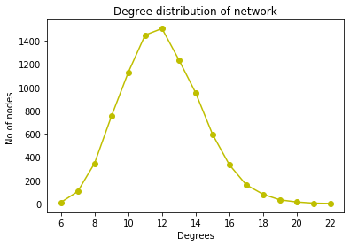
a) Degree distribution:

Fig 6. Degree distribution of Watts Strogatz model for dataset 3.

b) Average shortest path length : 3.9793208167294862
c) Average clustering coefficient = 0.02900195361959158

Average clustering coefficient is relatively low for dataset 3 as compared to dataset 1 and 2. Average shortest path length for dataset 1 is less as compared to dataset 2 and 3.

C. Barabasi Albert
Goal – Start with a small network of few nodes and understand how it grows by adding new nodes.
1. Tries to model “Prefential Attachment”
2. Likelihood of linking to a node is proportional to its current degree.
3. The greater the degree, the more edges it will get making its degree even greater.
4. Idea : Do not link new nodes uniformly and randomly but according to “Rich got Richer” scheme which is known to be heavy tailed distribution.

The function ‘barabasi_albert_graph(n,m,seed=None)’ is used to build the graph where n is number of nodes in a graph, m is number of edges to attach from a new node to existing nodes.

Dataset 1:
n = 7115
m = 10
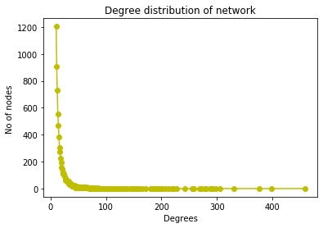
a) Degree distribution:

Fig 7. Degree distribution of Barabasi Albert model for dataset 1.

b) Average shortest path length : 2.986394173712678
c) Average clustering coefficient = 0.01411123151479387

Dataset 2:
n = 10876
m = 10
a) Degree distribution:
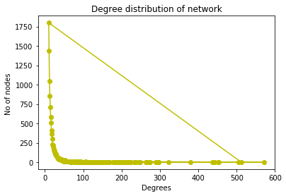

Fig 8. Degree distribution of Barabasi Albert model for dataset 2.
b) Average shortest path length : 3.0808283978643263
c) Average clustering coefficient = 0.0105220602424754

Dataset 3:
n = 8717
m = 10
a) Degree distribution:
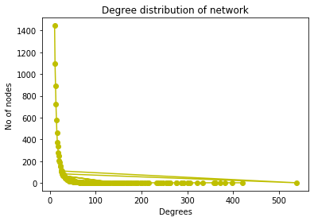

Fig 9. Degree distribution of Barabasi Albert model for dataset 3.

b) Average shortest path length : 3.0297813143629133
c) Average clustering coefficient : 0.012315596653276377

Average clustering coefficient of dataset 2 is relatively low as compared to other two dataset. Average shortest path length for dataset 1 is less as compared to dataset 2 and 3.

So, all the three models are observed with extracting the properties like average shortest path length, average clustering coefficient and degree distribution.

